Times Capsule Style Guide

Overview: The Times Capsule site features past Times Square Arts Projects for both a New Yorker and tourist audience. The site should emphasize the public art projects and artists themselves rather than TSArts as an organization so that the audience so the attention is brought to the art rather than the institution.

**FONTS**

Open Sans Condensed Bold is used for subtitles on the homepage and project descriptions.

ABCDEFGHIJKLMNOPQRSTUVWXYZ

ABCDEFGHIJKLMNOPQRSTUVWXYZ

abcdefghijklmnopqrstuvwxyz

1234567890

NEON LED Light is used for the Times Capsule title and project titles.**COLORS**

Abcedefghijklmnopqrstuvwxyz

1234567890

The sites main colors are black and white. Black background and white letters by default. The colors below are for the hover titles on the homepage.

#FF0000

#0000FF

#FFD700

#DDA0DD

**IMAGES:**

The site is heavily image-based. The home page landing page is modern photo of Times Square transitioning into the older photo.

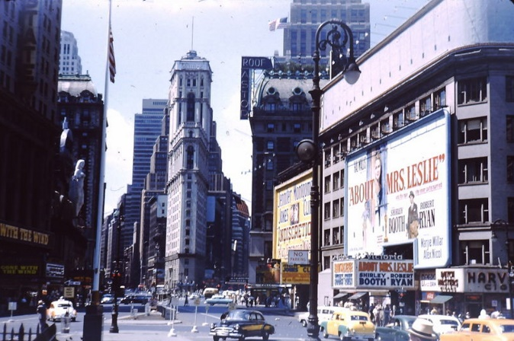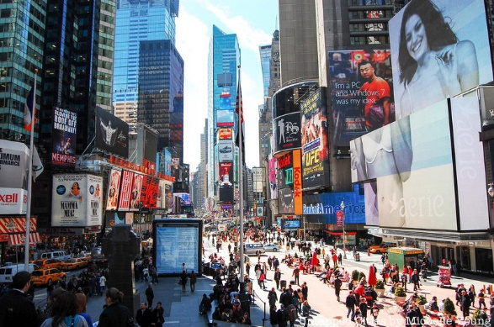

The projects below that use the most photos. The intention behind this section is too make it look like a found object piece, like a collage. That being the case images within the same project should overlap and beside that there isn’t much of a structure.

